Important to keep in the skin planner:
2. Skin Profile Management:
● Skin profile creation
● Skin type assessment
● Lifestyle tracking
● Sleep pattern tracking
● Hydration tracking
● Environmental exposure tracking
Skin Information:
● Skin Type Age
● Group Skin Concerns
● Allergies Sensitivities
● Lifestyle Habits
● Sleep Quality
● Water Intake
3. Skin Assessment Engine :
● Skin concern identification
● Skin health evaluation
● Skin condition scoring
● Concern prioritization
● Risk factor analysis
Common Skin Concerns:
● Acne
● Hyperpigmentation
● Dark Spots
● Dry Skin
● Oily Skin
● Sensitive Skin
● Wrinkles
● Fine Lines
● Redness
● Uneven Skin Tone
4. Personalized Routine Generator: ● Morning routine generation
● Evening routine generation
● Weekly treatment planning
● Seasonal skincare recommendations
● Adaptive routine updates
Routine Categories :
● Cleansing
● Exfoliation
● Treatment
● Moisturizing
● Sun Protection
● Night Care
5. Ingredient Intelligence:
● Module Ingredien
● Ingredient suitability assessment
● Ingredient interaction analysis
● Allergy detection
● Ingredient education
Ingredient Categories:
● Retinoids
● Niacinamide
● Vitamin C
● Hyaluronic Acid
● Salicylic Acid
● Ceramides
● Peptides
● AHAs/BHA
Skin types Images based you have inbuild or download the datasets fo that: If you don’t gonna use dataset you can inbuild like this
A. Skin Types In-Built Dataset (skin_types.json)
JSON
[
{
"id": "SKIN_TYPE_OILY",
"title": "Oily Skin",
"description": "Excess shine across the entire face, enlarged pores, prone to breakouts.", "image_url": "/assets/skin_types/oily.svg",
"backend_enum": "Oily"
},
{
"id": "SKIN_TYPE_DRY",
"title": "Dry Skin",
"description": "Feels tight, flaky patches, rough texture, less natural oil.", "image_url": "/assets/skin_types/dry.svg",
"backend_enum": "Dry"
},
{
"id": "SKIN_TYPE_COMBINATION",
"title": "Combination Skin",
"description": "Shiny T-Zone (forehead, nose, chin), dry or normal cheeks.", "image_url": "/assets/skin_types/combination.svg",
"backend_enum": "Combination"
},
{
"id": "SKIN_TYPE_SENSITIVE",
"title": "Sensitive Skin",
"description": "Easily turns red, stings, or reacts poorly to new products.", "image_url": "/assets/skin_types/sensitive.svg",
"backend_enum": "Sensitive"
}
]
Same Goes for Skin Concerns:
B. Skin Concerns In-Built Dataset (skin_concerns.json)
JSON
[
{
"id": "CONCERN_ACNE",
"title": "Active Acne & Pimples",
"description": "Whiteheads, blackheads, or inflamed breakouts.", "image_url": "/assets/concerns/acne.svg",
"backend_field": "acne_severity"
},
{
"id": "CONCERN_HYPERPIGMENTATION",
"title": "Dark Spots & Pigmentation",
"description": "Sun spots, uneven tone, or dark post-acne marks.",
"image_url": "/assets/concerns/pigmentation.svg",
"backend_field": "hyperpigmentation_severity"
},
{
"id": "CONCERN_REDNESS",
"title": "Redness & Rosacea",
"description": "Flushed patches, visible capillaries, or blotchiness.",
"image_url": "/assets/concerns/redness.svg",
"backend_field": "redness_severity"
},
{
"id": "CONCERN_WRINKLES",
"title": "Fine Lines & Wrinkles",
"description": "Smile lines, crow's feet, or loss of firmness.",
"image_url": "/assets/concerns/wrinkles.svg",
"backend_field": "wrinkles_severity"
}
]
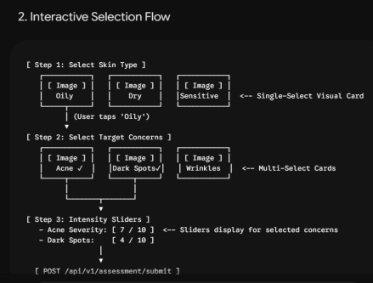
3. How the Payload Sends to the Backend
When the user selects the image card for Oily and checks Acne and Dark Spots, the React frontend formats the selections into the structured JSON payload required by the backend:
JSON
{
"user_id": "usr_99",
"skin_type": "Oily",
"acne_severity": 7,
"hyperpigmentation_severity": 4,
"redness_severity": 0,
"wrinkles_severity": 0,
"lifestyle": {
"sleep_hours": 7.5,
"water_intake_liters": 2.5,
"stress_level": 4,
"sun_exposure": "Moderate"
}
}
Note to Remember:
Eliminates Self-Diagnosis Errors: Users don't need to know medical jargon. They simply tap the picture that best mirrors their skin look and feel.
Clean Backend Compatibility: Because the dataset maps directly to standardized fields (skin_type: "Oily"), your scoring engine processes clean data without text parsing issues.
Low Complexity : Your won't need to build or train a heavy Computer Vision model just to let users pick their skin attributes. They simply serve static SVG/PNG cards from the /assets folder and pass structured parameters to the backend endpoints.
Deliveries:
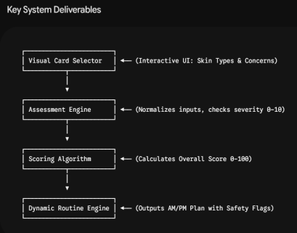
Summary of Modules & Workflows
1. In-Built Visual Dataset & Wizard UI
● Visual Card Selection: Users select their Skin Type (Oily, Dry, Combination, Sensitive) and Target Concerns (Acne, Hyperpigmentation, Redness, Wrinkles) using interactive visual cards (PNG/SVG illustrations + descriptive text).
● Severity Sliders: Selected concerns open intensity sliders (0to 10) to capture exact severity without complex medical jargon.
● Lifestyle Inputs: Simple numerical steps for sleep (hours/night), daily water intake (liters), and environmental exposure.
2. Weighted Skin Health Scoring Engine
Calculates a real-time Skin Health Score (0–100) based on clinical weights: $$\text{Skin Health Score} = 0.35(C) + 0.20(L) + 0.15(S) + 0.20(A) + 0.10(H)
● {C} (Condition - 35%): Penalized based on total severity of skin concerns. ● {L}Lifestyle - 20%): Evaluated against daily stress levels and sun exposure risk.
● {S}(Sleep - 15%): Evaluated against an optimal 8-hour sleep baseline.
● {A}(Adherence - 20%): Calculated from active 14-day completion logs (defaults to 100% for new assessments).
● {H}(Hydration - 10%): Evaluated against a 3.0L daily fluid benchmark.
3. Dynamic Routine Generator
Builds personalized morning (AM) and evening (PM) care calendars mapped to standardized categories (Cleansing, Exfoliation, Treatment, Moisturizing, Sun Protection, Night Care):
● AM Routine Pipeline: Gentle/Gel Cleanser $\rightarrow$
Antioxidant/Brightening Active → Lightweight Hydrator → Broad Spectrum SPF 30+.
● PM Routine Pipeline: Double Cleanse (Oil/Micellar + Water-based) → Targeted Active Treatment → Ceramide Barrier Cream.
● Safety Guardrails: Automatically flags sensitive skin profiles or severe redness (>7/10) to override harsh exfoliants and strong retinoids in favor of soothing actives (e.g., Centella Asiatica, Azelaic Acid).
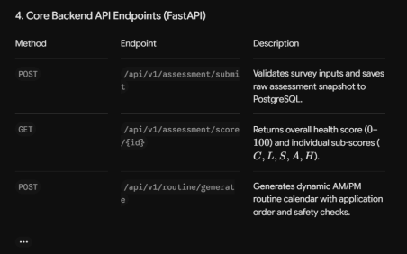5. Automated Testing & QA Criteria (Pytest)
● Scoring Accuracy Test: Asserts that optimal parameters yield a maximum sub-score weighting.
● Safety Exclusion Test: Confirms that sensitive skin profiles never receive high-concentration retinoids or harsh physical exfoliants. ● Routine Output Test: Verifies that mandatory steps (like morning sunscreen) are included in every generated AM routine.

